4 WEEK:

Name of the task : Searching for Javascipt

Estimate time of task : 3 hours

Actual time of task : 3 hours

# **What is JavaScript?**

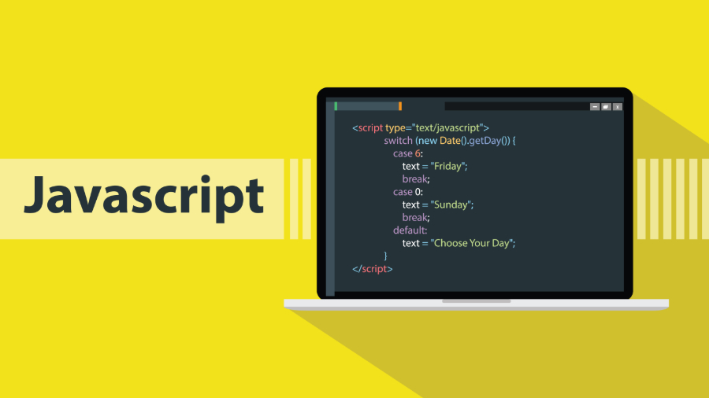

* It is a dynamic programming language commonly used in web browsers.
* JavaScript is the only programming language native to the web browser.
* JavaScript is the world's most popular programming language.

History:

It came out of the market in May 1995.

Brendan Eich.

## Why to Learn Javascript?Javascript ile Beni Unutma Yapalım

 I will list down some of the key advantages of learning Javascript:

* Javascript is the most popular **programming language** in the world and that makes it a programmer’s great choice. Once you learnt Javascript, it helps you developing great front-end as well as back-end softwares using different Javascript based frameworks like jQuery, Node.JS etc.
* Javascript is everywhere, it comes installed on every modern web browser and so to learn Javascript you really do not need any special environment setup. For example Chrome, Mozilla Firefox , Safari and every browser you know as of today, supports Javascript.
* Javascript helps you create really beautiful and crazy fast websites. You can develop your website with a console like look and feel and give your users the best Graphical User Experience.
* JavaScript usage has now extended to mobile app development, desktop app development, and game development. This opens many opportunities for you as Javascript Programmer.
* Great thing about Javascript is that you will find tons of frameworks and Libraries already developed which can be used directly in your software development to reduce your time to market.

## [What makes JavaScript unique?](https://javascript.info/intro" \l "what-makes-javascript-unique)

There are at least three great things about JavaScript:

* Full integration with HTML/CSS.
* Simple things are done simply.
* Support by all major browsers and enabled by default.

JavaScript is the only browser technology that combines these three things.

That’s what makes JavaScript unique. That’s why it’s the most widespread tool for creating browser interfaces.

That said, JavaScript also allows to create servers, mobile applications, etc.

## What is JavaScript used for?

JavaScript is mainly used for web-based applications and web browsers. . But JavaScript is also used beyond the Web in software, servers and embedded hardware controls. Here are some basic things JavaScript is used for:

### **1.     Adding interactive behavior to web pages**

JavaScript allows users to interact with web pages. There are almost no limits to the things you can do with JavaScript on a web page – these are just a few examples:

* Show or hide more information with the click of a button
* Change the color of a button when the mouse hovers over it
* Slide through a carousel of images on the homepage
* Zooming in or zooming out on an image
* Displaying a timer or count-down on a website
* Playing audio and video in a web page
* Displaying animations

### **2.     Creating web and mobile apps**

### **3.     Building web servers and developing server applications**

Beyond websites and apps, developers can also use JavaScript to build simple web servers and develop the back-end infrastructure using Node.js.

### **4.     Game development**

Of course, you can also use JavaScript to create browser games. These are a great way for beginning developers to practice their JavaScript skills.

**Javascript frameworks** and libraries

There are many useful **Javascript frameworks** and libraries available:

* Angular
* React
* jQuery
* Vue.js
* Ext.js
* Ember.js
* Meteor
* Mithril
* Node.js
* Polymer
* Aurelia
* Backbone.js

It is really impossible to give a complete list of all the available Javascript frameworks and libraries. The Javascript world is just too large and too much new is happening.

Setup:

* We use notepad ++ for javascript implementation.

Resources I used to learn:

<https://www.w3schools.com/js/js_datatypes.asp>

<https://www.javascript.com/try>

<https://www.tutorialspoint.com/javascript/index.htm>

My task next week: Continue researching Javascript.

Estimated duration: 3 hours